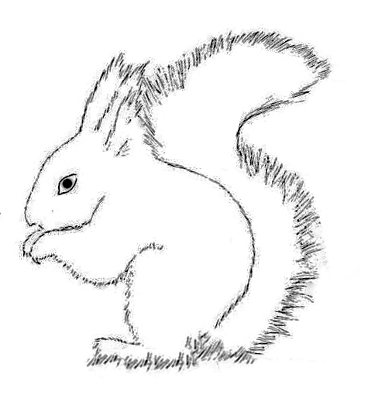

SQUIRREL SPRING WATCH
2018

Can you help? Many of us, together with our families and visitors, get great pleasure from watching red squirrels in our gardens, and the woods of our wonderful locality, and may also be concerned by the increasing appearance of grey squirrels.
Much good work is being done behind the scenes by individuals and also the dedicated volunteers of local red squirrel charities, and by land owners to control grey ingress. But it would be helpful to get a local snapshot of both red and grey squirrel populations and their distribution in Lorton Vale.
Can you help by reporting your red and grey squirrel sightings for a few days each month for a short trial period? Even if you rarely see squirrels where you live, null reports will also be really helpful. Don’t worry - Reporting will be simple!

Interested? Like to find out more? No commitment!

Email John at: jtmacfarlane@gmail.com

Thank you. John & Rosamund Macfarlane
Watergate Barn, Loweswater CA13 0RU Phone: 01900 85289



