John Stimpson Swift Boxes
UPVC/Plywood Heat and Rain resistant Model 30 £18.00 plus p&p
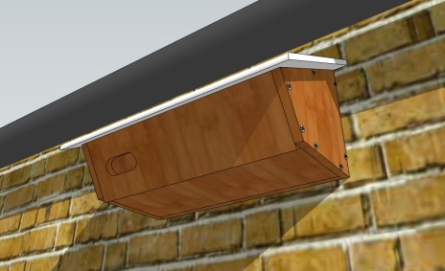
John Stimpson makes proven plywood nestboxes for use under eaves and on walls. He supplies two models: one for under eaves and one with an angled waterproof insulated heat-resistant white upvc roof for use on open walls, supplied fully assembled (illustrated above).
All nest boxes include an MDF nest form (lower right) - this simple device has been shown to speed take-up time by nesting Swifts by a year!
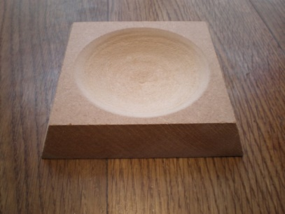
John Stimpson on 01353 740451or by e-mail EBwS@gmail.com
Where to fit Swift Nest Places
- optimum places are under deep eaves, on gables and on high walls in some shade
- not subject to disturbance from window cleaning or maintenance visits
- safe from potential attack by Squirrels, Crows and Magpies i.e. no adjacent perches or creepers
- at least 4.5 metres above ground level
- with uncluttered adjacent airspace for easy flight access

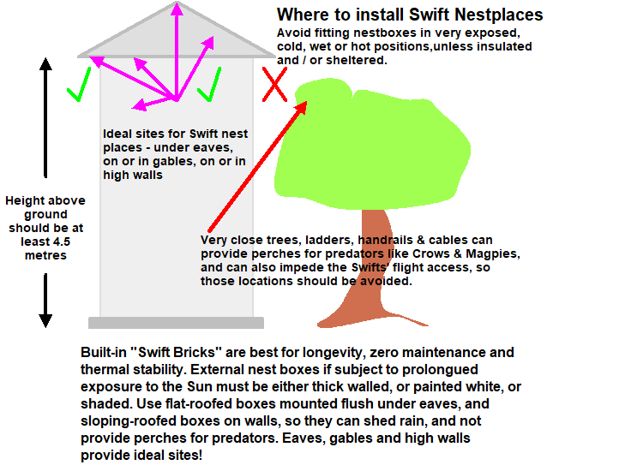

All nest boxes include an MDF nest form (lower right) - this simple device has been shown to speed take-up time by nesting Swifts by a year!
Both models of nest boxes are obtainable from
John Stimpson on 01353 740451
or by e-mail ( click here )

John Stimpson's  Low-cost Swift Nestboxes  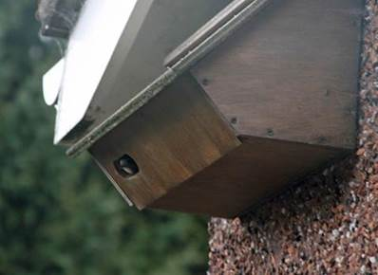 | Low cost UK-made plywood Swift Nest Boxes  So far 26,900 have been sold!  Two models available:  All-Plywood Zeist pattern £18.00 plus p & p  UPVC/Plywood Heat and Rain resistant Model 30 £18.00 plus p&p  John Stimpson makes proven (see photo on the left with a Swift chick visible in the box) plywood nestboxes for use under eaves and on walls.  He supplies two models: one for under eaves (illustrated left in use) and one with an angled waterproof insulated heat-resistant white upvc roof for use on open walls, supplied fully assembled.  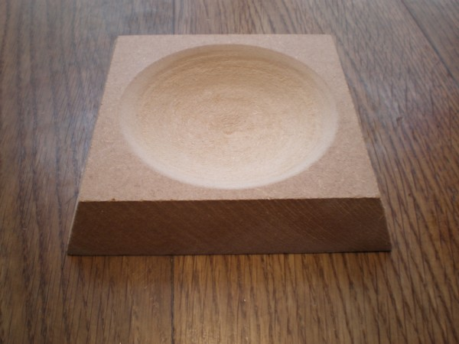  The entry hole size should exclude Starlings.  All nest boxes include an MDF nest form (lower right) - this simple device has been shown to speed take-up time by nesting Swifts by a year!  Both models of nest boxes are obtainable from  John Stimpson on 01353 740451  or by e-mail ( click here )
The RSPB's 
solid wood Swift Nestbox
