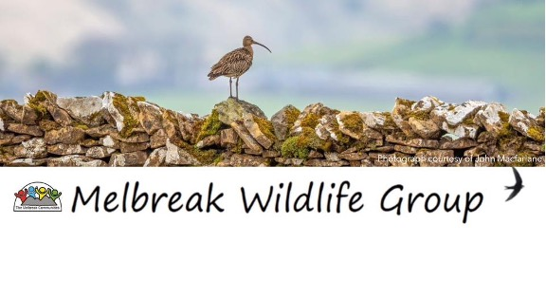Having a roof over one’s head makes a huge difference in life and so it is for some of our native wildlife. So far The Melbreak Communities Wildlife Group has installed pied flycatcher, swift and owl boxes. Here at Armaside Farm this year we successfully fledged six flycatcher chicks from a new box numbered 13. We have had pigeons in the owl boxes and sparrows in the swift boxes. It is all interesting and good fun.
Our bedroom this year was used by pipistrelle bats as a nursery. It wasn’t a very successful nursery unfortunately. We will install a couple of bat boxes on the OUTSIDE of the house for next year. One has to draw the line somewhere.
The Melbreak Communities has joined with the Cockermouth branch of the charity, Linking Lives. This charity aims to address loneliness and runs a befriending scheme. Go to: -https://linkinglives.uk/about/ for more information. Terry Peate is the Cockermouth Co-ordinator and he makes amazing wildlife boxes. So we’ve teamed up. Armaside Farm provides planks from trees grown on the farm, Terry makes the boxes and the full price of a box is equally divided between The Melbreak Communities and Linking Lives.
We have for sale various bird boxes and can customise the access holes to suit the type of bird, also swift, barn owl (inside and outside) tawny owl, bat and hedgehog boxes and hedgehog holes. You can find out more from our website and Facebook page. Or email glenis@borderhydro.co.uk. I think we rival Rightmove with our choice of housing stock!
The boxes are exceptionally sturdy and make excellent Christmas presents. They benefit much more than just the person receiving the gift. There are some boxes available now.
I’d like to encourage people living in The Melbreak Community parishes of Lorton, Loweswater, Buttermere and Blindbothel to use our website, melbreakcommunities.org.uk. We are in the middle of upgrading it but it is a good source of local information. You can also find us on Facebook at ‘The Melbreak Communities’ and for the wildlife information, ‘Melbreak Wildlife Group’ This will keep you up to date with all things wildlife and our Curlew Recovery project in particular. Join in and you will receive notifications of any new postings.
We will be hosting Coffee and Cakes at The Yew Tree Hall in Lorton on the 11th January 2025. Come along for some excellent fare and you can ask us about our various projects. You can also tell us about any ideas you may have.

Glenis Postlethwaite Chair for The Melbreak Communities.

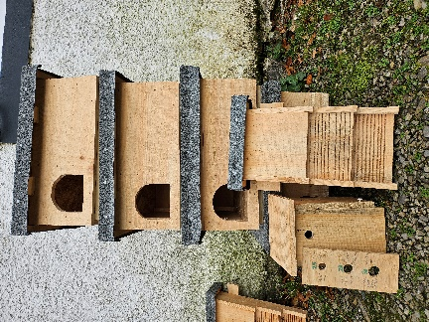  Our sturdy, natural boxes looking for new occupants. | Happy Christmas to the whole community from everyone involved with  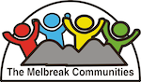

Wildlife Boxes price list

Hedgehog box £45
Barn Owls outside £50
Barn Owls Inside £40
Tawny Owl £30
Swift £15
All other bird boxes £10
Bat box £20
Hedgehog hole £3.

https://melbreakcommunities.wordpress.com/
https://www.facebook.com/groups/1047349900070904?locale=en_GB
https://www.facebook.com/search/top/?q=melbreak%20communities&locale=en_GB

