The Melbreak Communities
An Action Plan for the four parishes of Buttermere, Loweswater, Blindbothel and Lorton
www.melbreakcommunities.org.uk
Preparing for an emergency – Planning can save lives!

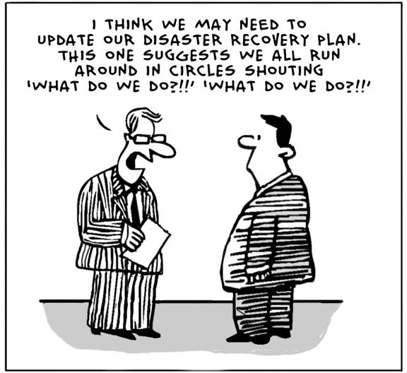

Emergency plan coordinators contact details: Steve Irlam 01900 85336

Low Lorton | Chris & Pip Wise | 01900 85561
High Lorton | Chris & Derek Poate | 01900 85265
Brackenthwaite | Debbie Watson | 01900 85317
Blindbothel | Alex Baker | 01900 85792
Loweswater | Carolyn Davis | 01900 85708
Buttermere | Richard & Yvette Kahane | 017687 70249
Mockerkin | Rachel Thompson | 01946 861053

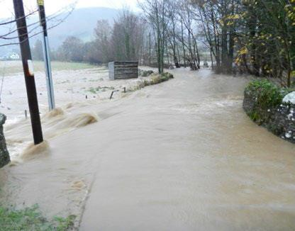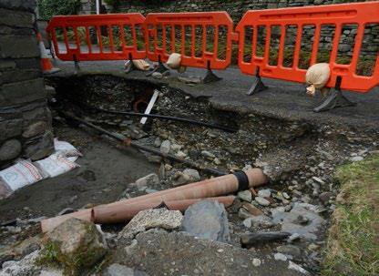

Flooding: Remember December 2015 and scenes of devastation like these?
We know too well what can happen, but here are a few things you can do:
- Identify if you are at risk of flooding by calling the Environment Agency Floodline on 0345 988 1188.
- Sign up to the Environment Agency Flood Warning Service.
- Get advice from the Environment Agency about how to flood proof your home.

If travelling in heavy rain please be aware of the following locations which are liable to flooding:
- Lorton Bridge
- Southwaite Bridge
- Scales Bridge
- B5298 Low Lorton Crossroads – the narrows
- B5298 Church Rd Junction – towards Cockermouth
- Thackthwaite North to Lorton Bridge alongside the river
- High Mill Bridge
- North shore / bank of Loweswater.
- B5292 north of Armaside Farm entrance.
- B5289 north of Cornhow
Severe weather events: This can include high winds, snowstorms, very heavy rain and flash flooding, prolonged periods of very low temperatures as well as drought.
- Listen for warnings of severe weather on radio and TV.
- Travel only if necessary: the conditions outside your door can worsen rapidly with location, time and altitude.
- Close and securely fasten doors and windows.
- Secure loose items which might blow about and cause damage, e.g. garden furniture, park your vehicle somewhere safe.
- Beware of unsafe structures (sheds, greenhouses, chimney pots) and trees around your home in high winds. If travelling, beware of fallen trees, icy roads, flash flooding.

Pandemic Flu / Covid:
'Flu pandemics arise as a result of a new virus circulating, against which few people have immunity. To reduce the risk of catching and spreading the virus:
- Follow government advice

Power Cuts / Water Contamination / Interruption of land line and mobile phone service:
These can happen at any time, but usually occur during severe weather events and flooding; and often in winter.
Precautions you can take:
- Know where all your isolation taps are for gas, water and heating oil and use them.
- Keep torches and a portable radio in good order, have spare batteries and some candles and matches.
- Keep a few litres of bottled water in the house (this keeps for months) together with spare baby food if necessary.
- If you use a telephone landline ensure that one phone in the house doesn’t need power to work properly (a simple fixed handset is best).
- Have a spare mobile phone battery or a means to charge it from your car.

GENERAL ADVICE FOR ALL EVENTS:
Make a family emergency plan, so that you all know what to do.
- Put together an EMERGENCY PACK and check it every 6 months.
- Agree how the family will stay in touch in the event of an emergency.
- Agree where you will meet up should you be separated and unable to return home.
- Keep family and friends’ phone numbers with you.
- Choose someone living away to be your family contact.
- Fill in the table for emergency telephone numbers (use a permanent marker) and put these into your mobile phone memories.
- Make provision for your pet(s) - who will look after them?

Your EMERGENCY PACK should contain the following:
- Wind-up or battery RADIO + TORCH + spare batteries.
- First Aid kit and manual.
- Medication, repeat prescriptions, toiletries, tissues, sanitary supplies.
- Special food or equipment for infants, the elderly, and people with disabilities.
- Spare warm clothing and waterproofs.
- Sleeping bags or blankets.
- Books, playing cards or games.
- Mobile phone, spare battery and car charger.
- Extra car and house keys.
- Copies of important family documents, (e.g. birth certificates, passports, licenses and insurance documents). Keep these in a fireproof/waterproof container.
- Cash, credit cards, key cards, ID passes.

You should have access to the following if services are blocked for several days:
- Several litres of bottled water.
- Portable stove or barbecue but remember not to use a barbecue indoors or in an unventilated area due to the risks from carbon monoxide.
- Three days’ emergency food supplies.

What to do if you stay at home: “GO IN – STAY IN – TUNE IN”
- GO INSIDE A SAFE BUILDING
- Call 999 if people are injured or there is a threat to life.
- Follow the advice of the emergency services.
- Do not put yourself or others in danger.
- STAY IN until advised to do otherwise.
- TUNE IN to local radio or TV for information.

Children at school:
- Do not attempt to collect them, it may not be safe to do so. They will be cared for until conditions allow them to be collected.
- Tune into local radio for information and advice.

What to do if you have to leave home:
- Follow instructions of Emergency Services.
- You may be asked to go to a reception centre.
- Take your emergency pack and this leaflet with you.
- Take your mobile phone and charger.
- Call your family contact and tell them where you are going.
- Turn off electricity, gas, water; unplug appliances, lock all doors and windows.
- If leaving by car, take bottled water and blankets: tune into Radio Cumbria.
- Don't forget your pets.

Equipment which may be available and useful during emergencies:
- Pumps
- Sandbags
- Generators
- 4 x 4 vehicle
- JCB / Tractor

RADIO CUMBRIA FREQUENCIES:
AM = 756 & 1458, FM = 95.6 & 104.1

IMPORTANT PHONE NUMBERS:

POLICE | 101 or 0300 124 0111
ENVIRONMENT AGENCY | 0800 80 70 60
ELECTRICITY | 105 or 0800 195 4141
WATER | 0345 6723 723
TELEPHONE (BT Line) | 151
TELEPHONE (wires & poles) | 0800 023 2023
DOCTOR.......................................................................
HOSPITAL …………………………………………………………………
DENTIST.......................................................................
BUILDINGS INSURANCE ..............................................
CAR INSURANCE .........................................................
HOUSE CONTENTS INSURANCE..................................
PLUMBER/ELECTRICIAN .............................................
SCHOOL.......................................................................
VET...............................................................................

