What are your thoughts on the key outputs? Are there any others you believe we should be considering?
Please note - Concern that is often highlighted as a key issue is parking. However, that is not something that can be addressed by the current project. The matter of parking in the village needs to be fully explored on a wider community level.

INITIAL IDEAS

We have been looking at different ways to meet the objectives, with many working sketches being produced to incorporate our various ideas (see displays). We very much welcome your comments and would like to hear any ideas you may have.

NEXT STEPS ...
To move the project beyond the ideas stage and into reality, we really need to appoint a professional team, including an architect, flood risk assessor, quantity surveyor and mechanical and electrical engineer. This professional team will allow us to develop our plans, and most importantly, cost the scheme. Virtually all major funders of projects like this one, require a costed scheme with planning approval, before they will consider a funding application.
The development group is currently exploring ways to secure the funding needed to appoint the professional team that is vital to move the project forward. This will be a challenge as there are very few, if any, funding pots available to pay for this feasibility work. Although we have some funding secured already, additional support from community members will be needed. Therefore, we are currently looking into various fund raising options, including establishing a "Friends of Yew Tree Hall" Group. In the meantime, if you wish to make a contribution, please contact us at ythlorton@gmail.com
The group is very keen to ensure that members of the community have every opportunity to contribute to the project and are fully aware of what is proposed. We intend to hold events to provide updates and listen to ideas. Regular updates will be provided via The Link, Melbreak Communities website, Parish Council magazine, and dedicated leaflets.
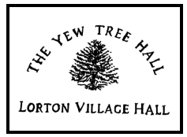

DEVELOPMENT GROUP MEMBERS:
Cathy Lee (Chair), Adam Baker, Peter Deeks, Rachael Edmonds, Steve Irlam, Derek Poate
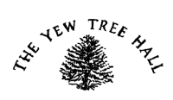
IMPROVEMENT PROJECT

VISION

"To build upon Yew Tree Hall’s history and redevelop it to ensure it continues to provide a valuable, useable asset for the local community"

THE YEW TREE HALL DEVELOPMENT GROUP
In response to the community's preference to explore re-development of existing buildings before other options are considered, we have been working on some great ideas for the improvement of Yew Tree Hall.
Key to the success of this project is ensuring that the local community are fully aware of what is proposed, and that you have adequate opportunity to be involved in the project. We are keen to hear your thoughts on what you would like to see as part of the Hall's redevelopment.
Yew Tree Hall is a grade II listed building. Formerly a malt house, built by the Jennings brewery family in 1828, its listing reflects the prominent role brewing played in the industrial development of Lorton. The basement still houses valuable industrial heritage features from its original brewing operation, such as the vaults and kiln structure
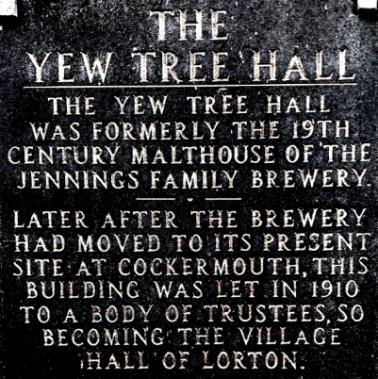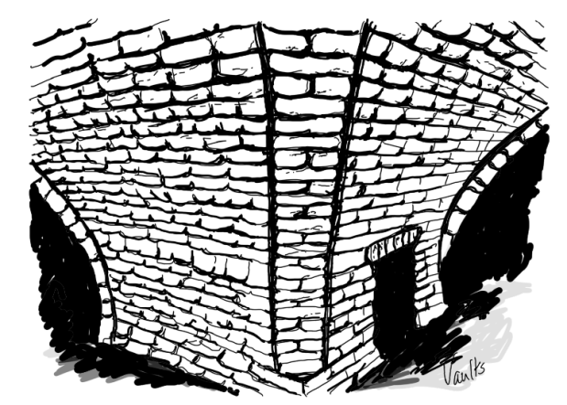

Our vision and objectives reflect the need to improve the existing facilities, particularly in terms of accessibility for all, whilst appreciating the heritage value of the Hall.

KEY OBJECTIVES
The redevelopment will:
- Ensure the Hall is accessible to all and has facilities that can be used by all, including toilets
- Create a safe, welcoming space that can be used by the whole community for a wide range of activities and events
- Improve the energy efficiency and environmental sustainability of the building
- Enhance the historic elements of the Hall and explore opportunities this presents
- Continue to be able to accommodate up to 100 people
- Improve the physical relationship between the Hall and surrounding public space
ANALYSIS OF CURRENT FACILITIES
Strengths
- key community asset in the heart of the village
- regularly used for a wide range of activities
- heritage asset - important part of the village's history
- well equipped kitchen
- capacity for up to 100 people
- fully serviced
Development areas
- limited accessibility (wheelchairs, pushchairs, less mobile currently cannot access due to steep steps to gain entrance)
- Internal access issues - not all on a flat level once in hall
- Inefficient – difficult to heat/heat loss
- Lack of accessible toilets
- Key heritage features ‘hidden away’
- Lack of storage space for large pieces of equipment – takes up otherwise useable space
- Poor acoustics

KEY PROJECT OUTPUTS

- Accessible to all
- Incorporate the following into the hall:
  - Main hall all on one level
  - Kitchen on the same level as the hall
  - accessible toilets
  - Separate smaller meeting space able to be used at same time as the main hall
  - Storage space
  - Integrated audio visual

As part of the redevelopment we also want to take the opportunity to enhance the heritage value of the building

- Retaining as many heritage features as possible, particularly vaults and kiln structure
- Improving access to the buildings heritage features

